Test Case: tc003_SPX_Dev5_Crear_Requisicion_Spot_Tipo_Cobro_CC_Urgent
Step 1 - Enter username and password and click to button Enter : Credentials Entered
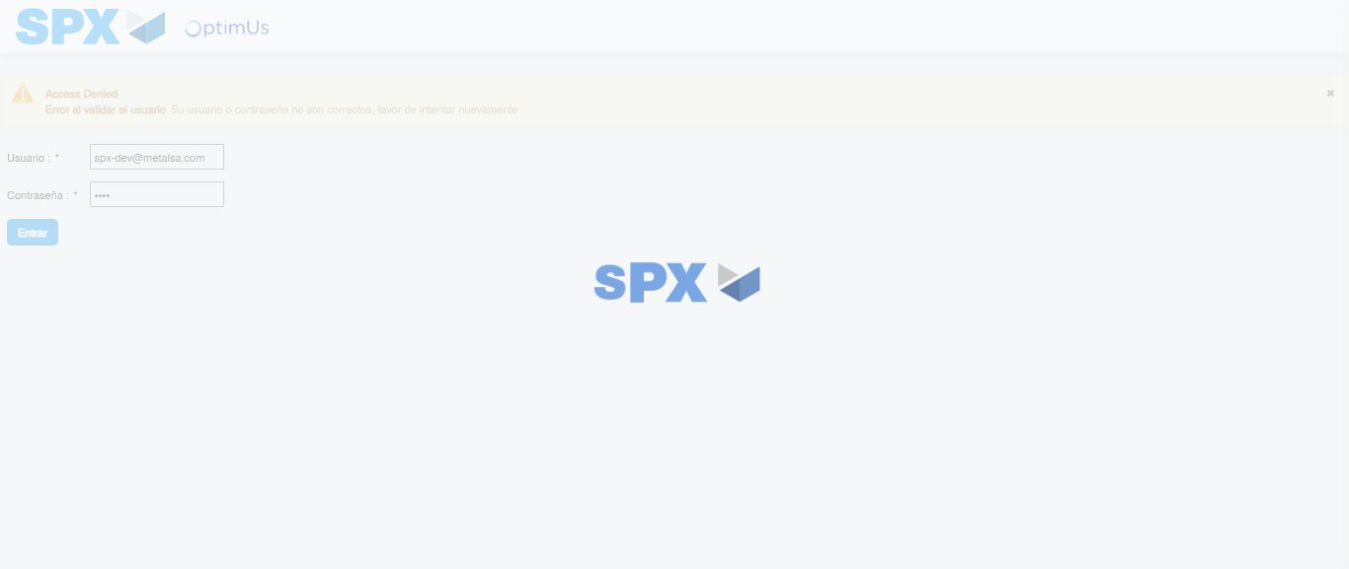Image file-name: QC_Testing-tc003_SPX_Dev5_Crear_Requisicion_Spot_Tipo_Cobro_CC_Urgent-1785344489680

Step 2 - Select to UEN and Access to Spot Buy Requisitions : UEN Correctly selected and Correct access
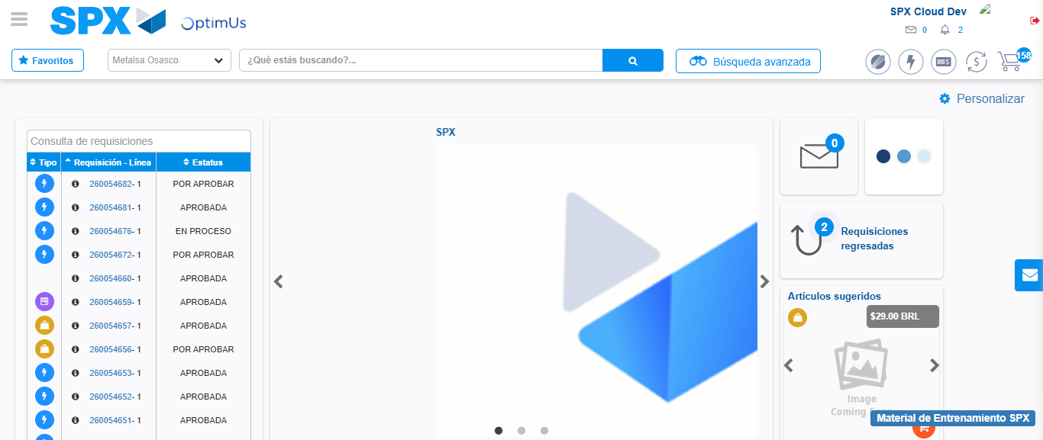Image file-name: QC_Testing-tc003_SPX_Dev5_Crear_Requisicion_Spot_Tipo_Cobro_CC_Urgent-1785344514961

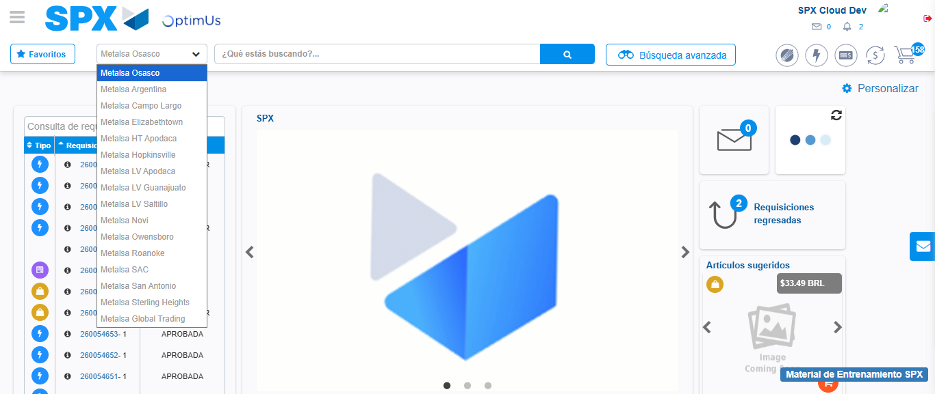Image file-name: QC_Testing-tc003_SPX_Dev5_Crear_Requisicion_Spot_Tipo_Cobro_CC_Urgent-1785344517580

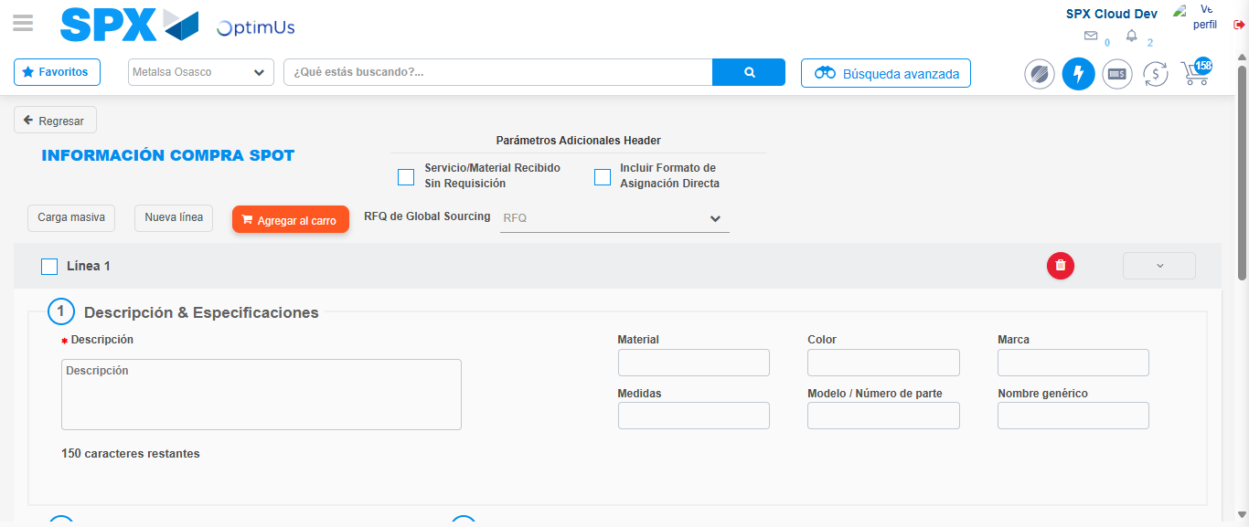Image file-name: QC_Testing-tc003_SPX_Dev5_Crear_Requisicion_Spot_Tipo_Cobro_CC_Urgent-1785344540886

Step 3 - Data Capture Spot Buy Requisition: Data captured correctly
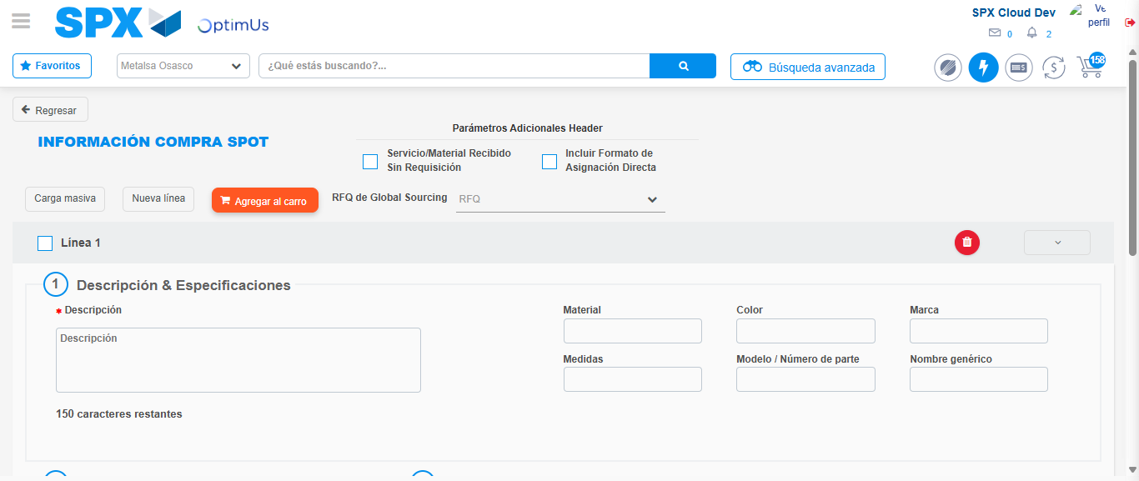Image file-name: QC_Testing-tc003_SPX_Dev5_Crear_Requisicion_Spot_Tipo_Cobro_CC_Urgent-1785344541157

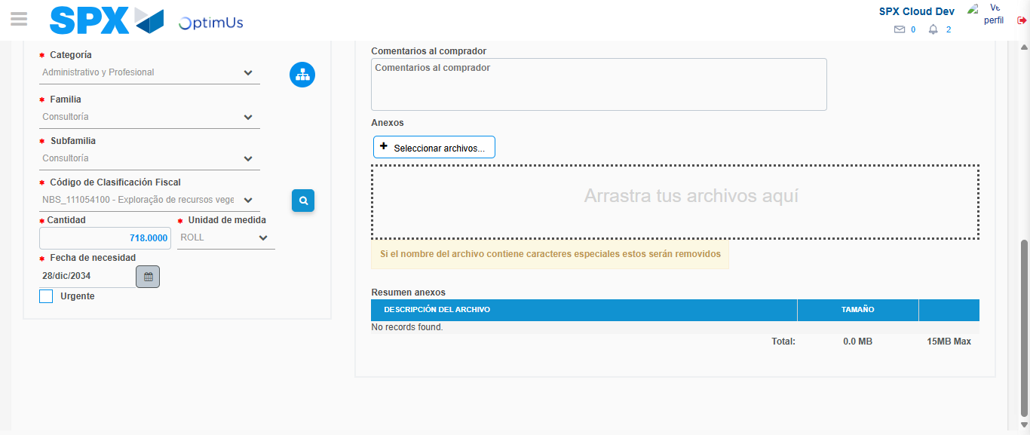Image file-name: QC_Testing-tc003_SPX_Dev5_Crear_Requisicion_Spot_Tipo_Cobro_CC_Urgent-1785344554967

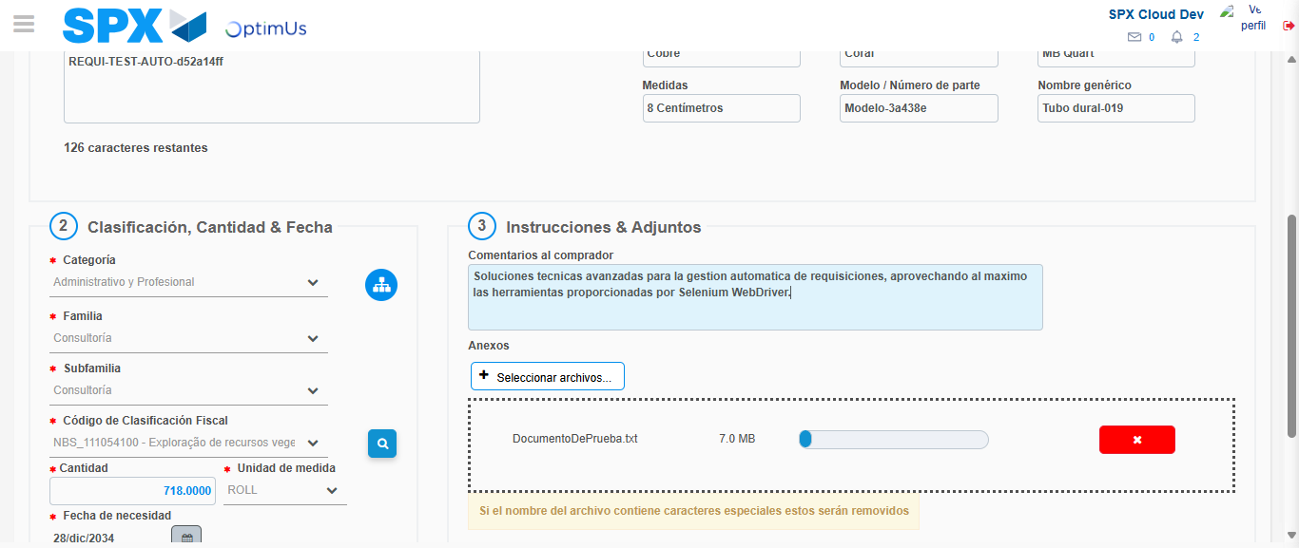Image file-name: QC_Testing-tc003_SPX_Dev5_Crear_Requisicion_Spot_Tipo_Cobro_CC_Urgent-1785344555686

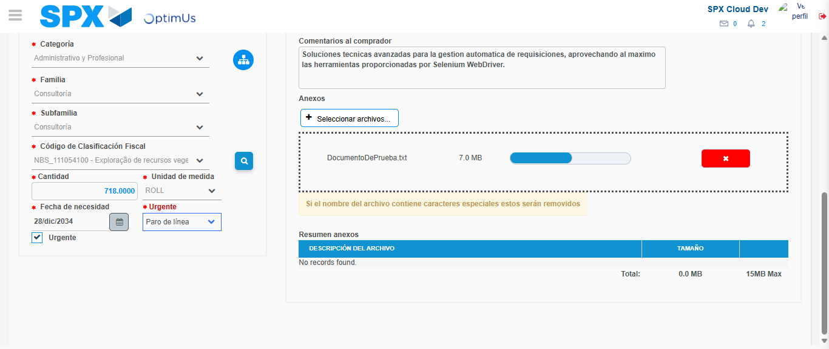Image file-name: QC_Testing-tc003_SPX_Dev5_Crear_Requisicion_Spot_Tipo_Cobro_CC_Urgent-1785344558810

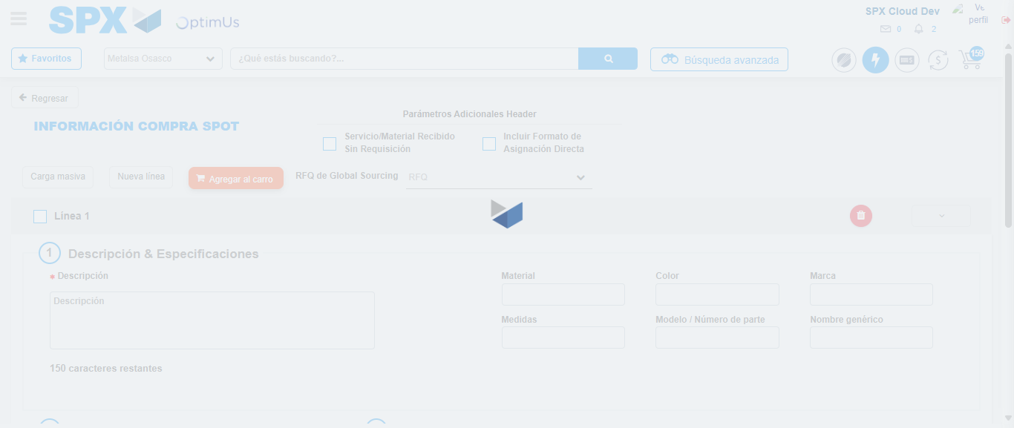Image file-name: QC_Testing-tc003_SPX_Dev5_Crear_Requisicion_Spot_Tipo_Cobro_CC_Urgent-1785344561314

Step 7 - Return to Main Page SPX : Return to Main Page SPX
Image file-name: QC_Testing-tc003_SPX_Dev5_Crear_Requisicion_Spot_Tipo_Cobro_CC_Urgent-1785344514961

Image file-name: QC_Testing-tc003_SPX_Dev5_Crear_Requisicion_Spot_Tipo_Cobro_CC_Urgent-1785344517580

Image file-name: QC_Testing-tc003_SPX_Dev5_Crear_Requisicion_Spot_Tipo_Cobro_CC_Urgent-1785344540886

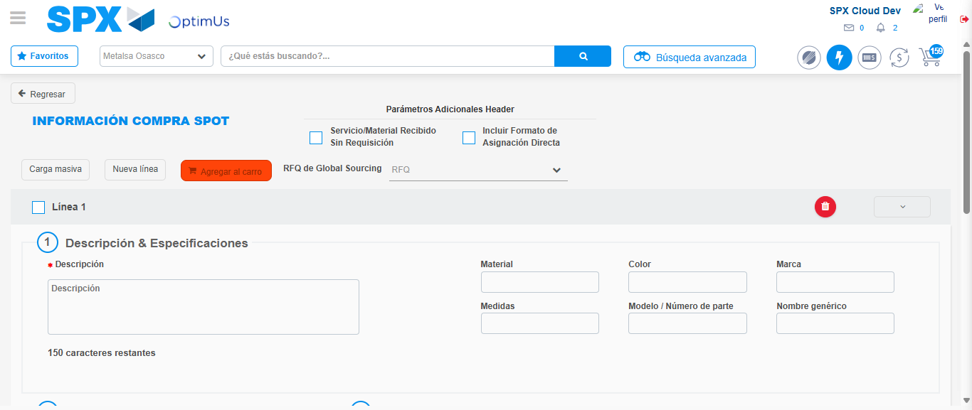Image file-name: QC_Testing-tc003_SPX_Dev5_Crear_Requisicion_Spot_Tipo_Cobro_CC_Urgent-1785344563528

Image file-name: QC_Testing-tc003_SPX_Dev5_Crear_Requisicion_Spot_Tipo_Cobro_CC_Urgent-1785344563677

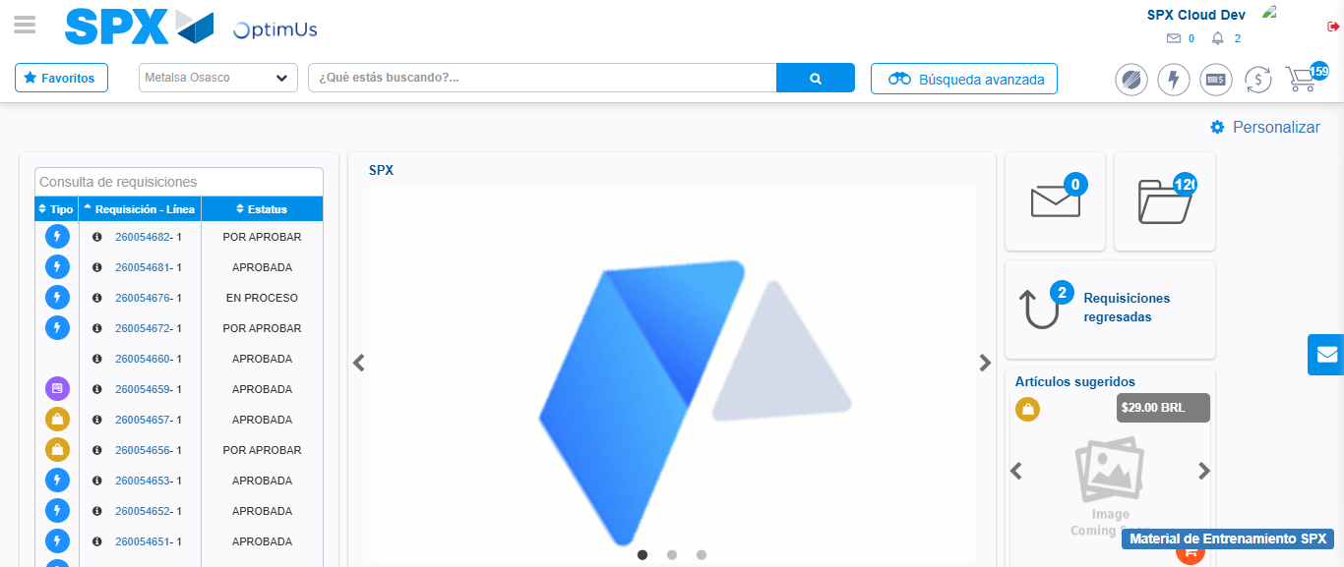Image file-name: QC_Testing-tc003_SPX_Dev5_Crear_Requisicion_Spot_Tipo_Cobro_CC_Urgent-1785344584699

Step 8 - Log Out : Log Out SPX
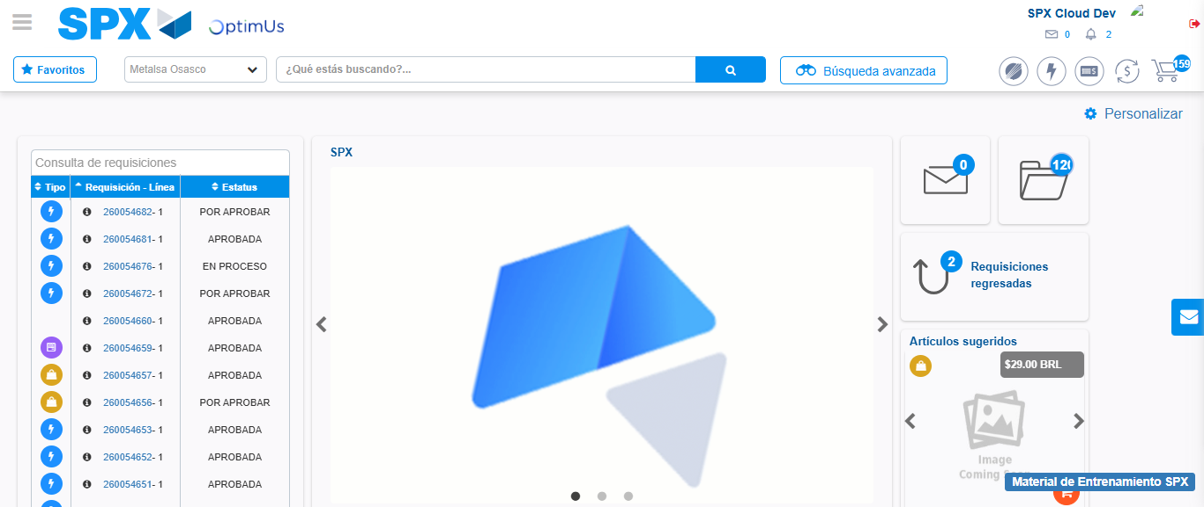Image file-name: QC_Testing-tc003_SPX_Dev5_Crear_Requisicion_Spot_Tipo_Cobro_CC_Urgent-1785344584975

